`
Invites you to a one day workshop
Treating Targets of School Bullying
presented by
Evelyn Field OAM, FAPS, Psychologist

Date: Friday, 20th October 2017

Time: 9.30am. to 4.30pm. Registration and Coffee from 9am.

Venue: CANBERRA – venue to be announced

Registration fees: $319 (GST incl) Morning tea, afternoon tea and lunch provided

Super Early Bird Special: 20% discount for those people registering and paying in full
by 20th August 2017

Early Bird Special: 10% discount for those people registering and paying in full by 20th September 2017

Full time students receive a 20% discount – a copy of your current student card needs to be sent with your registration form.

Workshop description:
Some students experience bullying behaviours at school and manage to block them, get support or move away. Others may be seriously injured, physically, psychologically, socially or cognitively.
Evelyn’s training program for psychologists, school counsellors and social workers include theory and practical strategies. Her treatment has been clinically proven (Carroll, 2007) and is simple and brief, averaging 4-6 sessions.
In the first part of this workshop, Evelyn will provide participants with a basis for understanding bullying, its causes, short and long-term injuries, damage to students, school and community and how schools and parents can manage it.
Evelyn believes that developing social and emotional resilience is essential for survival, and empowers students to connect, relate and block school bullying, using her six step social survival skills model.
The remainder of the workshop will focus on the treatment process, from the initial interview through to subsequent interactions with the child and parent and treatment goals. Evelyn will also introduce some methods to help the child identify and change inadequate communication skills and develop effective bully blocking techniques.
Topics covered in the workshop:
- Bully blocking at school
- The role of the school
- ‘Secrets of relating’: social survival skills for targets, bullies, peers and adults
- The role of the therapist.

Learning outcomes:
At the conclusion of this event, participants will have gained understanding of:
- Exactly why bullying is harmful
- What the school can do to reduce and manage bullying
- The six essential social survival skills to develop social resilience
- The role of the therapist to treat a bullied child effectively

About the speaker:
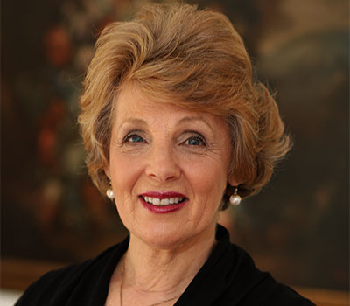
Evelyn Field is a practicing psychologist and professional speaker, recognised for her expertise in working with young people and adults who have been bullied or victimised. Evelyn has developed a sijmple six-step model to help them deal with the consequences of bullying and acquire techniques to protect themselves for the future. She is the author of two best-selling books, Bully Busting and Bully Blocking, now in five languages. She has also written Bully Blocking at Work and Strategies for Surviving Bullying at Work. Evelyn specialises in understanding school and workplace bullying and helping those affected by it as well as encouraging organisations to respect their students/employees and the latter to develop resilience in dealing with difficult people. The core of her work is her social survival skills model.
Venue:
The workshop is to be held in Canberra. We are currently finalising venue arrangements and will add this information as soon as possible.

