Invites you to a one day workshop

**Most AD/HD parent training programs fail!**

**Learn the art of working with families with AD/HD to maximise successful outcomes.**

presented by

**Dr Caroline Stevenson, Clinical Psychologist**

|  |
| --- |
| **Date:** **Friday, 16th June 2017**  **Time:** 9.30am. to 4.30pm. Registration and Coffee from 9am.  **Venue:** PARRAMATTA RSL CLUB, Cnr Macquarie and O’Connell Sts, Parramatta  **Registration fees**: $319 (GST incl) Morning tea, afternoon tea and lunch provided  **Super Early Bird Special**: 20% discount for those people registering and paying in full  by 16th April 2017  **Early Bird Special**: 10% discount for those people registering and paying in full by 16th May 2017  **Full time students** receive a 20% discount – a copy of your current student card needs to be sent with your registration form. |

**Workshop description:**

In this workshop, parenting programs for children with AD/HD will be evaluated. It will be argued that clinicians working in this field need to understand the executive functioning difficulties of AD/HD and modify parenting resources. This workshop will have a practical focus and will explain the key parenting strategies that improve functioning in the homes of children with AD/HD.

Learning outcomes:

* To gain a thorough understanding of Brown’s AD/HD Model
* To obtain a knowledge of the research on AD/HD and parenting
* To gain a good understanding of the limitations of current parenting programs
* To understand strategies that work for children with AD/HD and why.

**About the speaker:**

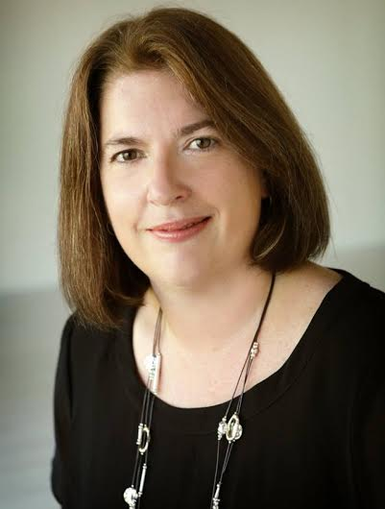Caroline Stevenson graduated from the University of Sydney in 1999 with a Masters degree and a PhD in Clinical Psychology. For her PhD she developed and evaluated the first behavioural treatment program for adult AD/HD. This research has been recognised by the NHMRC, and by international scientists and clinicians, as a milestone in the management of this condition.

Caroline has had an on-going commitment to teaching and research. She has worked at Macquarie University and at The NSW Institute of Psychiatry, most recently supervising the first clinical trial evaluating the effectiveness of the 1-2-3-Magic child behaviour program. She has taught in academic settings on AD/HD, learning difficulties, and child and adolescent behaviour problems, and presented at medical and scientific conferences on these topics. She has also supervised other clinical psychologists in practice, as well as Masters and PhD students. She has been extensively involved with peak community organisations supporting people with AD/HD, currently serving on the board of AD/HD Australia.

Working in a range of clinical settings since graduation, Caroline has amassed an extensive range of experience relating to the management of AD/HD and its associated problems in children, adolescents and adults. This has included working as a clinical psychologist for the Sydney Children’s Hospital Learning Difficulties Clinic, The Prince of Wales Adolescent Service and The Northern Beaches Adolescent Service.

**Venue:**

Parramatta RSL is about a 10 minute walk from Parramatta Station. Alternatively there is a free Loop bus from Parramatta station, which runs every 10 minutes, and stops in Macquarie St near the RSL. There is a cark park available across the street from the RSL club, which can be entered via Macquarie St where there is LIMITED free parking if you get your ticket stamped by the RSL Club before leaving. There is also user-pay parking available in Hunter St.

[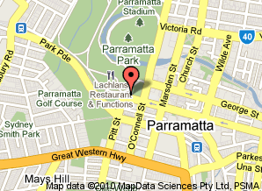](http://maps.google.com.au/maps?q=Parramatta+RSL+Club,+Parramatta,+New+South+Wales&hl=en&cd=4&ei=4h4gTNXCLZewvAPK3oXLCA&sig2=-yYIslEvFbR66hnZRjKaZQ&ie=UTF8&view=map&cid=1888775444911331595&iwloc=A&ved=0CBgQpQY&sa=X)